CORRECTION D´EXERCICES
P. 37 EX. 5
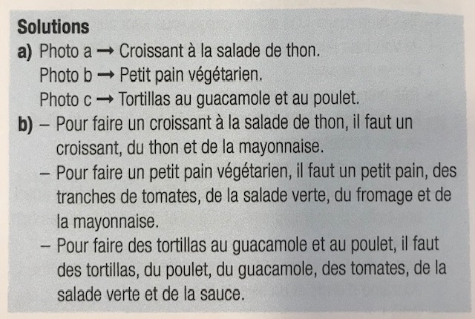

P. 37 EX 7

P.37 EX. 6
