CARS, TRAINS, BIKES, PLANES, SLOW AND FAST
A Webquest for ESO-English
Designed by
Neus Bonet Farran
nbonet3@xtec.cat
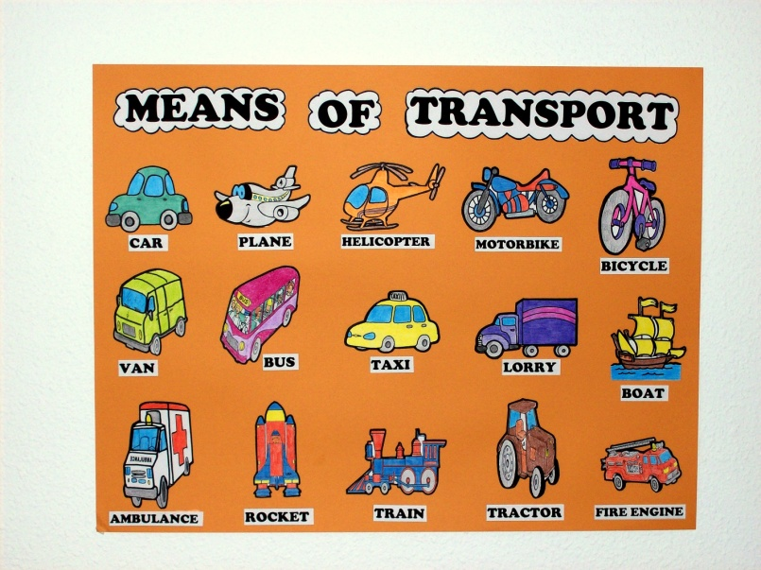
Introduction | Task | Process | Evaluation | Conclusion | Credits | Teacher Page
Introduction
Do you like travelling?
What do you prefer, travelling fast or slow?
Do you worry much about what type of clothes to pack?
In this webquest you can discover how transportation and clothes have changed over the years. Since there is a shortage of teachers in your school, the principal has asked you and your team to teach your classmates a lesson in English about the History of Modern Transport and the History of the clothes people used when travelling. You will have to do some research before introducing this topic to the class.
Are you ready?

The Task
Your task is to show your classmates the evolution of transportation along history together with the changes in travelling clothes. You have to be very clear and persuasive in your presentation since your classmates will evaluate your work. Think of the best way you can teach this subject as a teacher.
The way you will introduce this topic to the class will be through Power PointPresentation where you can add a song in English related to the topic.
The Process
- You will work in a team of 4 students

- The whole team will work together in carrying out the first task “Timeline” . Write the Timeline on a sheet of paper or in a Word Document.

- Two members of the team will work on the Means of Transport and the other two on Clothes.

- For the description of the vehicles write down on a piece of paper or in a Word Document the make of the vehicle, the date, its shape, material, size, the way it works (fuel, steam, gasoline ...) and other characteristics you think are important (eg noisy, bumpy, comfortable, fast...). Make whole sentences, not just words.

- For the description of the clothes, write down on a piece of paper or in a Word document; eg. the date, the material, the shape, the fit (tight, loose...), the lenght and any other characteristics you think are important. Make whole sentences, not just words.

- The whole team will make a Power Point to introduce the topic to the class. In this Power Point you will include images of the vehicles and clothes you have chosen and a description for each one of them. You will also tell the students about the conclusion you have reached about the evolution of Modern Transport and Clothes over the years.

Resources

Victorian Inventions
http://www.woodlands-junior.kent.sch.uk/homework/victorians/inventions.htm

Victorian Inventions Timeline
http://www.woodlands junior.kent.sch.uk/homework/victorians/inventiotimeline.html

Victorian Transport
http://www.woodlands-junior.kent.sch.uk/homework/victorians/carriages.html

The Bicycle

http://www.pedalinghistory.com/PHhistory.html

Trains

http://inventors.about.com/library/inventors/blrailroad.htm

Cars
http://inventors.about.com/library/weekly/aacarssteama.htm

http://www.si.edu/Encyclopedia_SI/nmah/earlycars.htm#History

Ships
http://library.thinkquest.org/04oct/00450/historyofsail.htm

Motorbikes
http://www.ukwheels.com/motorbikes.asp

http://ezinearticles.com/?The-History-of-Motorbike&id=2132608

Clothes
http://www.localhistories.org/clothestime.html
http://www.angelfire.com/ar3/townevictorian/victorianfashion.html
http://www.uen.org/utahlink/tours/tourFames.cgi?tour_id=13227

Evaluation

Beginning Developing Accomplished Exemplary Score
1 2 3 4

Delivery
Individual
Not clear, confusing
Many grammar,l vocabulary and pronunciation errors. Not always clear but good try
Some grammar, vocabulary and pronunciation errors but clearly understood
Very few grammar and vocabulary errors. Good pronunciation. Very clear

Power Point Presentation
Group
Boring, not interesting
Some parts are
interesting and some aren’t
Interesting
Very good presentation and very interesting

Team work
Lack of cohesion. There is no team work in the presentation
Good try at delivering the information as a team but unsuccessful results
Good team work
Excellent team work

Research
Poor use of information given in the Resources
Good try at researching information but not accurate
Good and accurate research
Excellent research showing creativity and autonomy

Interest in the task

No interest at all
Some interest but not engaging
True interest
Very engaging

You will be evaluated both, in group and individually by the teacher and by your classmates.

Conclusion

The task you have completed in this webpage will help you improve your English as well as your knowledge about History.
Another important issue is that you may have learnt what it is like to introduce a topic to a class and to prepare a lesson as if you were a teacher.

Credits & References

I thank the following webssites for their information:

Woodlands junior Kent School UK
Inventors Library
Bicycle Museum
About.com
Encyclopedia Smithsonian
Oracle Think Quest
UKWheels
Ezine Articles
Local Histories Clothes
Angel Fire

Last updated on August 15, 1999. Based on a template from The WebQuest Page

