WEEKS 4 AND 5. LEAFLET OF A CITY OR A (PART OF A) COUNTRY

Due date (data màxima d’entrega): 17th May

This time you have two weeks to do the task!!

Hi everybody!
I hope you’re fine!! We’re going to finish unit 5. These two weeks, you’re going to create a travel brochure of a place you want.

These weeks you have to do only 1 activity (writing)

Aquestes dues setmanes heu de triar un país, una part d’un país o una ciutat (el que preferiu) i fer un tríptic turístic (un full amb informació del lloc). Ha d’ocupar un full de paper per davant i per darrere.

What do you have to include in it?
- Name of the city / country…+ a title that is attractive (per fer que la gent vulgui visitar el lloc).
- A short description of the place.
- Location and how to get there (you can include a map)
- Photos or drawings of the place
- Information about what you can do in the place (monuments, museums, important streets, parks, outdoor activities like sports, typical food…)
- Information of interest (like restaurants, hotels, timetables of the places to visit…)
- Other information that you think it is important

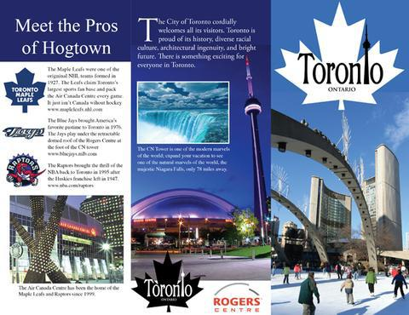
Examples:

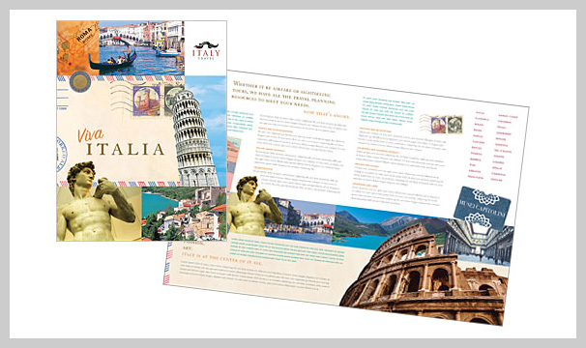

You also have an example in your student’s book, on page 69. Here are the pictures.

Follow these steps:
- Choose a part of the country, a whole country or a city.
- Look for information about the place and decide what information you want to use in your travel brochure (what monuments, things to do, information of interest…?).
- Design the travel brochure (how many parts is it going to have? what pictures, drawings, maps are you going to include?). It must be beautiful and attractive for tourists.
- Write the information in the brochure.
- And send it to me!

Com podeu fer el disseny??
Si el feu a ordinador, aquí teniu unes quantes pàgines on trobareu plantilles gratis per utilitzar:
- https://www.flipsnack.com/templates/brochures/travel
- https://www.lucidpress.com/pages/templates/brochures/travel-brochures?source=blog
- https://www.canva.com/templates/search/travel-brochures/

També el podeu fer amb una altra aplicació que conegueu o al Word, fent el disseny vosaltres (pot estar dividit en tres columnes, com un tríptic o els dos fulls de paper sense dividir).

Si no teniu ordinador o no el podeu utilitzar, podeu fer-lo a mà.

Si teniu problemes, envieu-me un correu o en parlem a la trobada pel ZOOM.
Grup A-B: DIMECRES 12:30-13:00
Grup C-D: DIMECRES 12:00-12:30

EMAIL: laia.montge@gmail.com

