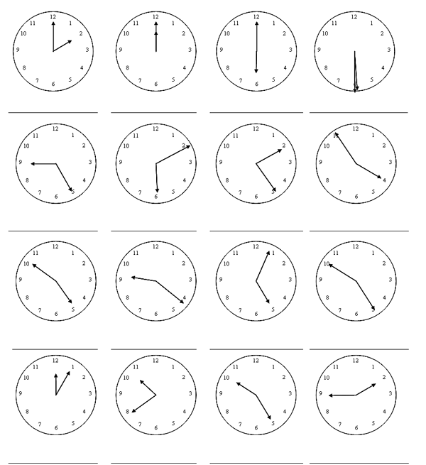

**What time is it? Write the correct hour.**